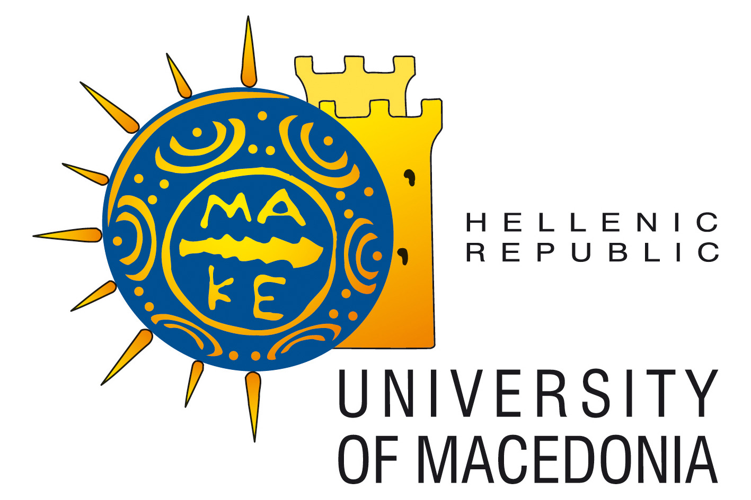

SCHOOL OF SOCIAL SCIENCES, HUMANITIES AND ARTS

DEPARTMENT OF INTERNATIONAL AND EUROPEAN STUDIES

MASTER’S DEGREE IN INTERNATIONAL PUBLIC ADMINISTRATION

The Department of International and European Studies invites applications for its new course of studies leading to a Master’s Degree in International Public Administration. The aim of this course is to provide students, employees in the public and private sector as well as people considering a career change with an education that will prepare them for employment in International Organizations, the Diplomatic Service or in positions where knowledge of the International System and its functions is important.

The course consists of three semesters, two of which require class attendance, while the third is dedicated to the writing of a dissertation. During the third semester students are not required to reside in Thessaloniki.

The language of instruction is English.

Subjects taught are as follows:

First Semester
- International Relations Theory
- Diplomacy and Global Governance
- Principles of Public Administration
- International Law
- The International Economic System and its Institutions

Second Semester
- Decision Making and Mediation
- International History and the International System
- European Union Government and Politics
- International Human Resources Development
- Armed Conflict: Theory and Law

Third Semester
- Dissertation

All subjects are mandatory.
Faculty members include Dr Ilias Kouskouvelis, Dr Theodosios Karvounarakis, Dr Christos Nikas, Dr Dimitrios Skiadas, Dr Spyridon Litsas, Dr Foteini Bellou, Dr Kalliopi Hainoglou.

Tuition fees: 3600 € payable in two installments

Accommodation is not provided but students can access the program’s website for recommendations.
Meals can be purchased at moderate prices in the school cafeteria.

Applicants must be University graduates and have a good knowledge of the English language certified by Cambridge or Michigan Proficiency or English speaking university degree or by a minimum TOEFL score of 79 (Computer based) or 213 (Internet based) or by a minimum IELTS score of 6.5.

Please send
- a completed application form found at “www.mipa.uom.gr”
- certified academic transcripts of university degree translated into English or Greek where appropriate
- proof of proficiency in English
- two letters of reference
to: The Postgraduate Secretary
Department of International and European Studies
University of Macedonia
4th floor, building KZ
Egnatia 156
54636 Thessaloniki, Greece

Additional qualifications, such as job experience or additional languages and degrees, although not required, will be taken into consideration.

Following an initial selection, interviews will be conducted by phone or Skype (Please include in your application your phone number and/ or Skype account). Once admitted, candidates with undergraduate degrees NOT awarded by Greek Universities will also need to have their degrees recognized by the Greek authorities (Hellenic National Academic Recognition Information Center “DOATAP”). Detailed information on this issue can be obtained from the Secretary. Please consult the following link for a list of universities whose degrees are recognized by the Greek State http://62.103.84.30/2.php.

Thessaloniki is a lively seaside city with more than 100,000 students. It is full of history and local color with many recreational opportunities.

Application deadline is 14 September 2015.

Applications will be processed as soon as they are received and places in the program will be offered within a short period of time. Applicants are advised to apply early to ensure a place in the program. Course begins on Monday, October 5th 2015.

For further information, please contact the Postgraduate Secretary at mipa@uom.gr or 0030 2310 891507.

The Program Director

Dr Theodosios Karvounarakis
Associate Professor

