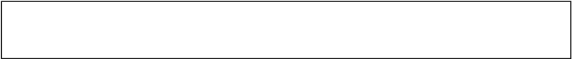
Public Health Passenger Locator Form: To protect your health the public health officials, you should fill out this form whenever there is a suspect for infectious airborne illnesses and / or you come from a country where there is an epidemic of an infectious disease. Your information will help the public health officials to contact you if you are exposed to a contagious disease. It is important to fill out this form completely and accurately. Your information is held in accordance with applicable laws and is used for public health purposes only.
~ Thank you for helping us to protect your health.

One form should be filled out by an adult member of each family. Leave blank box for spaces.

Flight info: 1. Name of company 2. No. of flight 3. No. of seat 4. Arrival date (dd/mm/yy)

 |  |  |  |  |  |  |  |  |  |  |  |  |  |  |  |  |  |  |  |  |  |  |  |  |  |  |  |  |  |  |  |  |  | 2 | 0
Personal information: 5. Surname 6.Name 7. Initial of middle name 8. Sex

m f

Phone numbers that you would be available if necessery. Including coutry code and city code.

9. Mobile 10. Work

11. Home 12. Other

13. Email address Permanent address:

14. Street and number (separate with empty box)

15. No. of appartment

16. City 17. State/province

18. Coutry 19.Postal code

Temporary addres: If you are a visitor name the first place where you will stay.

20. Name of hotel (if any) 21. Street and number (separate with empty box) 22. No. of apartment/room

23. City 24. State/province

25. Country 26. Postal code

Contat information (in case of emergency) by someone who can contact you in the next 30 days

27. Surname 28. Name 29. City

30.Country 31. E-mail

32. Mobile phone 33. Other phone

34. FELLOWTRAVELLERS – MEMBERS OF FAMILY: Includes only minors (under 18 years)

Surname Name No. of seat Age <18

(1) (2) (3) (4)
35. FELLOWTRAVELLERS – NOT MEMBERS OF THE FAMILY: Include the name of the group (if any)

Surname Name Group (toursit,team, etc)

(1)

(2)

